**Name >> Muhammad Huzaifa**

**Roll No >> 04**

**Assignment 1**

**5th August 2023**

**Module 2 : Front End Development**

*Submission Requirements: Please upload your codes in PDF File on Google Classroom in the relevant Assignment section.*

*Note: Plagiarism is a serious violation. Zero marks will be awarded in case plagiarism is found.* You are required to perform the following tasks.

# Part 1:

Task 1:

Embed the provided iframe element with the source "https://www.corvit.com" and set its width to 100% and height to 400px.

**Solution:**

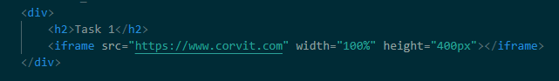



Task 2:

Add a new button below the iframe with the text "Click Me." When the button is clicked, display an alert with the message "Button clicked!"

**Solution:**

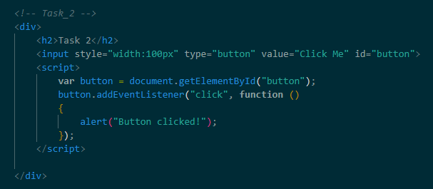

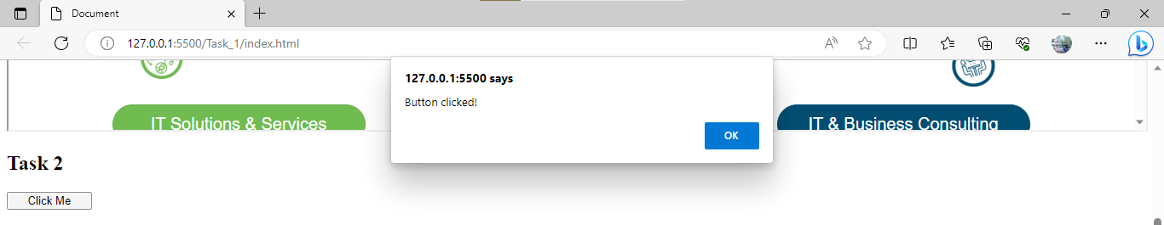

Task 3:

Include a video element below the button. Use the provided video file "video.mp4" as the source. Enable video controls, autoplay the video, and mute the audio.

**Solution:**

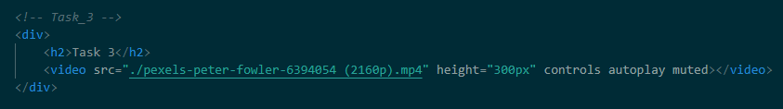

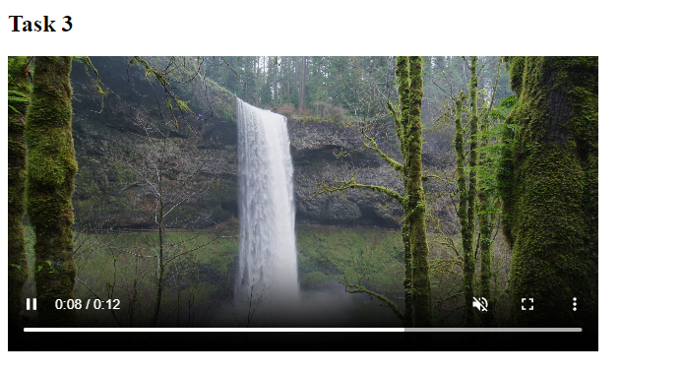

Task 5:

Create an anchor link (a) below the video element. Set the link's href attribute to "./form.html" and add the target attribute to open the link in the same browser tab.

**Solution:**

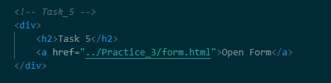

Task 6: Add an image to the page. Use any image of your choice and set its width to 300px and height to 200px.

**Solution:**

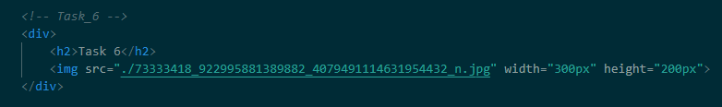

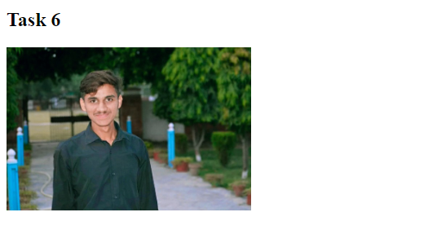

Task 7:

Create an ordered list (ol) with at least three list items (li) containing the names of your favorite books.

**Solution:**

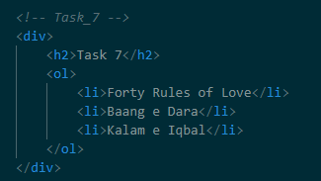

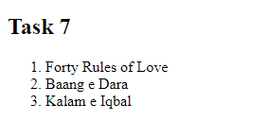

Task 8:

Add a horizontal rule (hr) below the ordered list to visually separate it from the rest of the content.

**Solution:**

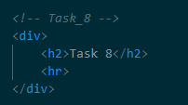



Task 9:

Include an audio element on the page. You can use any audio file format and set the controls to display audio controls to the user.

**Solution:**

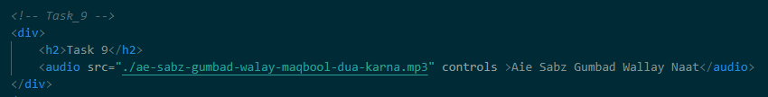

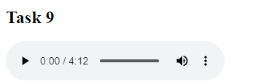

# Part 2:

Task 1:

Create a form with a text input field for "Name" and a drop down select element for "Country." The drop down should contain options for Pakistan, UK, USA, and UAE.

**Solution:**

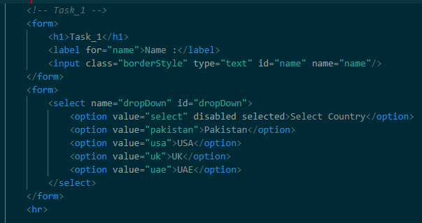

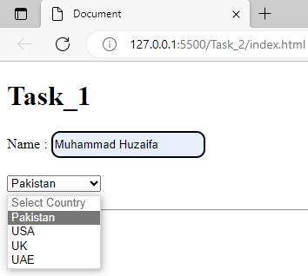

Task 2:

Implement a form with a textarea for users to enter a message with a maximum length of 100 characters.

**Solution:**

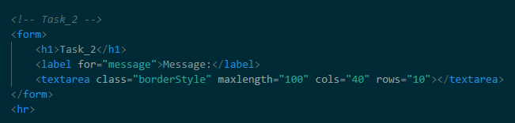

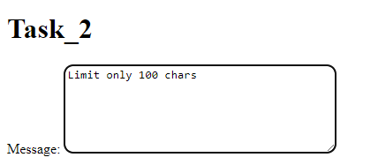

Task 3:

Create a form with a password input field and a checkbox to accept terms and conditions. The checkbox should be labeled "I agree to the terms and conditions."

**Solution:**

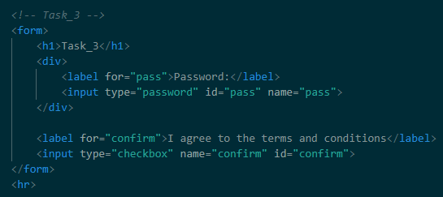

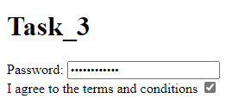

Task 4:

Design a form with three radio buttons for "Gender" selection: Male, Female, and Other.

**Solution:**

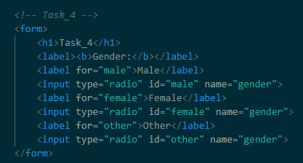

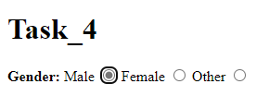

Task 5:

Add a file input field to the form that allows users to upload an image.

**Solution:**

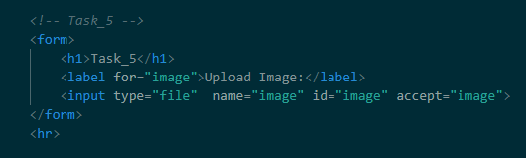

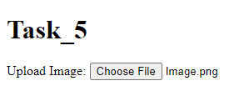

Task 6:

Implement a form with a range input element that allows users to select a value between 1 and 100.

**Solution:**

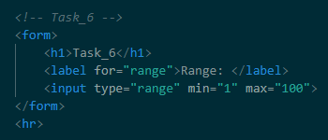

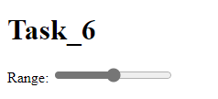

Task 7:

Create a form with a number input field for "Age" that only allows values between 18 and 65.

**Solution:**

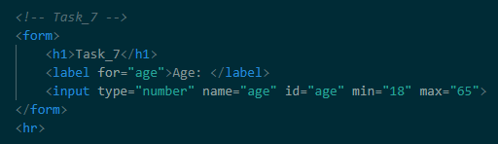

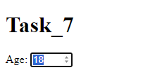

Task 8:

Design a form with a color input field that lets users choose a color.

**Solution:**

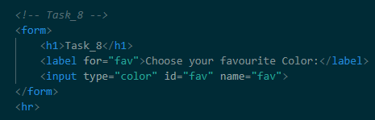

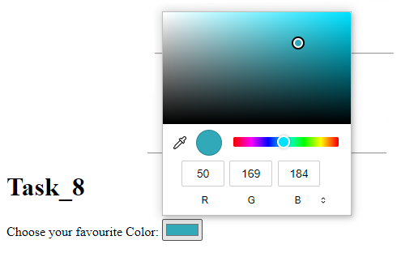

Task 9:

Add a date input field to the form to allow users to select a date.

**Solution:**

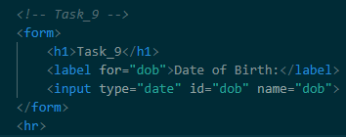

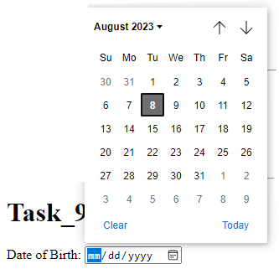

Task 10:

Create a form with a URL input field that requires users to enter a valid URL starting with "http://" or "https://".

**Solution:**

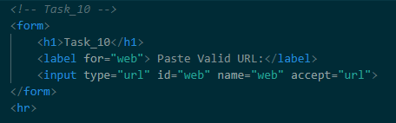

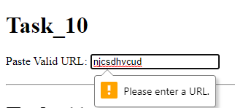

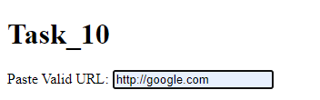

Task 11:

Implement a form with a number input field for "Quantity" that allows values between 1 and 10 only.

**Solution:**

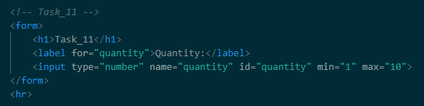

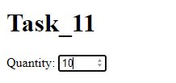

Task 12:

Create a form with a checkbox group for "Interests." Include checkboxes for "Sports," "Reading," "Cooking," and "Traveling."

**Solution:**

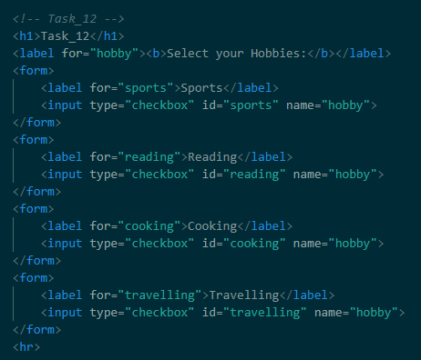

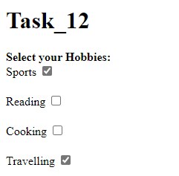

Task 13:

Design a form with a select dropdown for "Favorite Color." Include options for "Red," "Blue," "Green," "Yellow," and "Purple."

**Solution:**

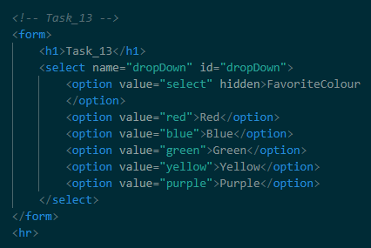

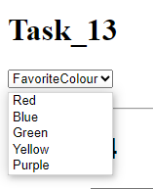

Task 14:

Add a time input field to the form, allowing users to select a specific time.

**Solution:**

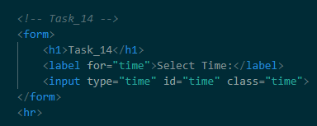

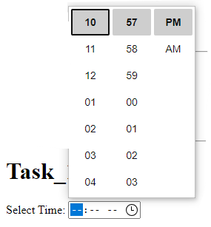

Task 15:

Implement a form with a search input field and a submit button. The search field should have a placeholder text, "Search here."

**Solution:**

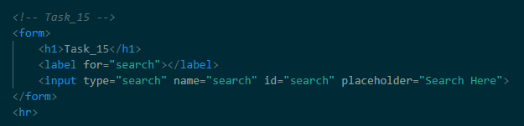

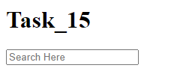

Task 16:

Create a form with a set of radio buttons for "Membership Plan." Include options for "Basic," "Premium," and "Pro."

**Solution:**

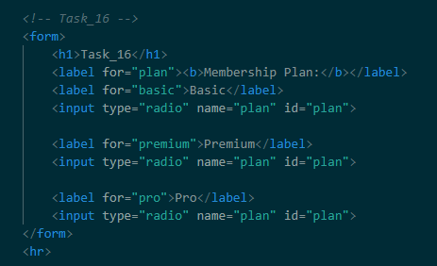

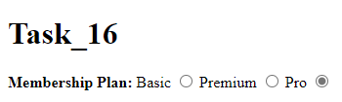

Task 17:

Design a form with a color input field and a submit button. When users choose a color and click the submit button, change the background color of the form to the selected color.

**Solution:**

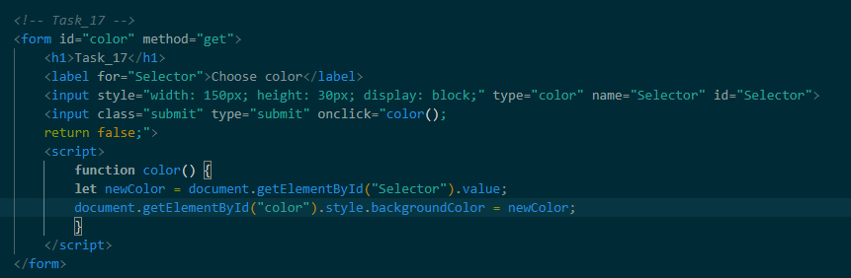

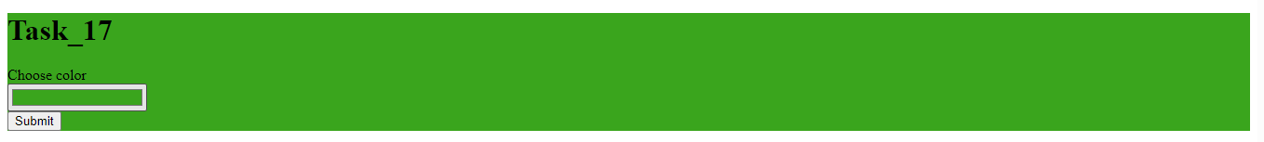

Task 18:

Add a week input field to the form, allowing users to select a specific week.

**Solution:**

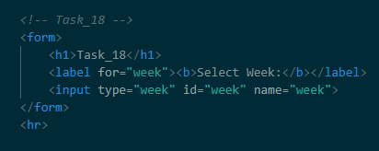

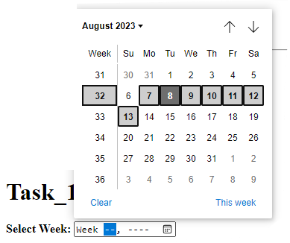

Task 19: Implement a form with a range input for "Rating" that allows values between 1 and 5.

**Solution:**

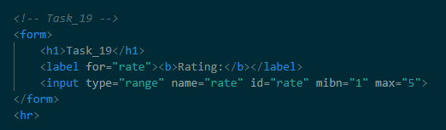

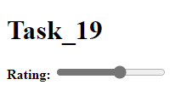

Task 21:

Design a form with a range input for "Volume" that allows values between 0 and 100. Include a label to display the selected value dynamically as the user adjusts the slider.

**Solution:**

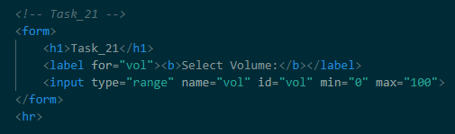

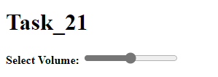

Task 22:

Create a form with a date input field and a time input field. Allow users to choose a specific date and time.

**Solution:**

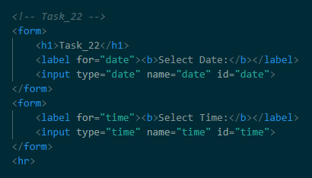

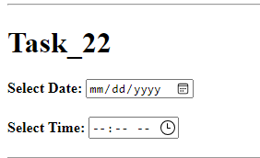

Task 23:

Implement a form with a file input field that allows users to upload a PDF file only.

**Solution:**

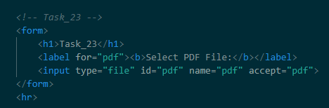

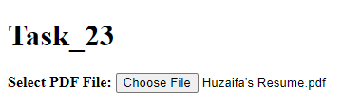

Task 24:

Design a form with a dropdown select element for "Age Group." Include options for "Child," "Teenager," "Adult," and "Senior."

**Solution:**

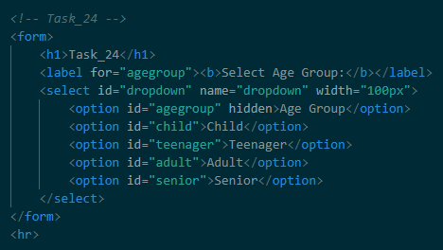

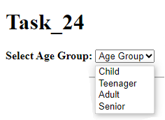

Task 25:

Create a form with a checkbox for "Subscribe to Newsletter." Include an input field for the user's email address, which should only be enabled when the checkbox is checked.

**Solution:**

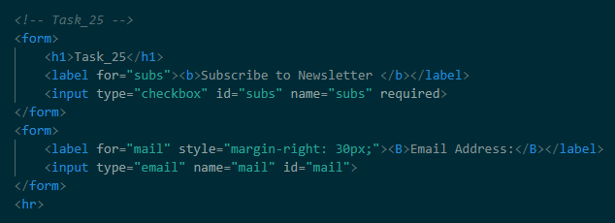

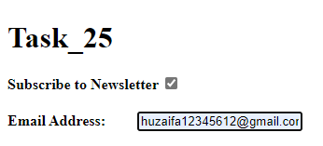

Task 26:

Implement a form with a radio button group for "Preferred Language." Include options for "English," "Spanish," "French," and "German."

**Solution:**

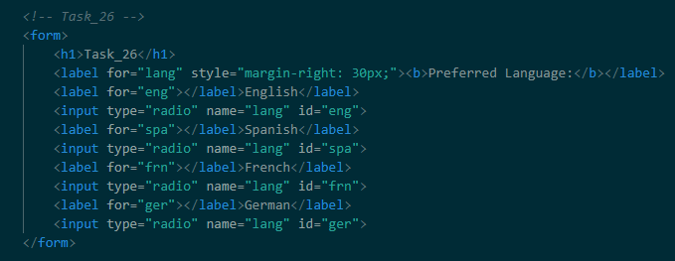

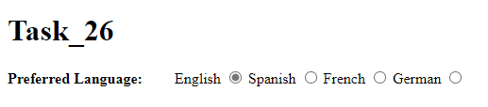

Task 27:

Design a form with a number input field for "Quantity" and a dropdown select element for "Unit." Include options for "kg," "lbs," "pieces," and "liters."

**Solution:**

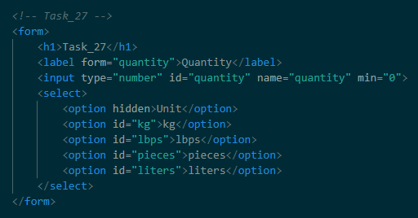

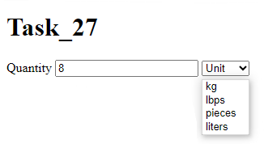

Task 28:

Design a form with a checkbox group for "Skills." Include checkboxes for "Programming," "Design," "Communication," and "Leadership."

**Solution:**

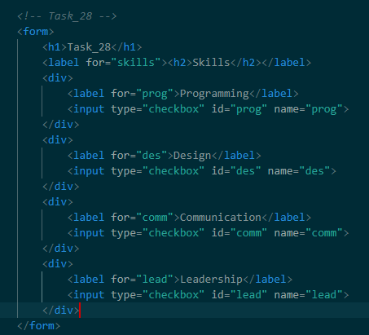

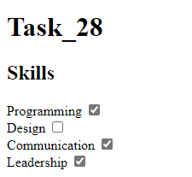

***Make sure each form element is properly labeled and has appropriate attributes for validation and usability. Test the forms to ensure they work as expected.***